[[https://collaborate.northwestern.edu/owa/14.3.158.1/themes/resources/clear1x1.gif](https://collaborate.northwestern.edu/owa/)Wiesenthal photo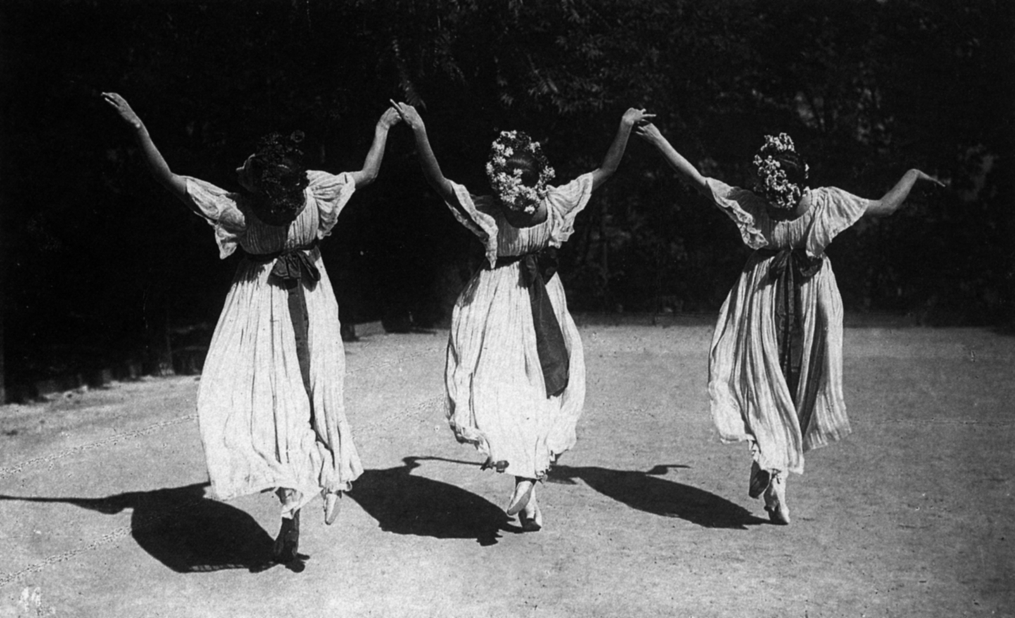graph.jpg‎ (1 MB‎)](https://collaborate.northwestern.edu/owa/" \o "Wiesenthal photograph.jpg" \t "_blank)

Elsa, Grete and Berta Wiesenthal in *Lanner-Schubert-Waltz* (1908). Photographer: Rudolf Jobst.

Permission to publish must be sought from the Derra de Moroda Archive in Salzburg.